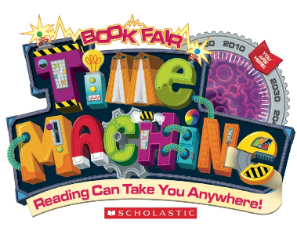
Join us for our second virtual book fair
Save The Date

Our school’s Book Fair is going online, so save the date! From Monday April 5th- Monday April 19th, discover the newest books hot off the press, from the comfort of your home.
Bonus: Every purchase supports our school and keeps kids’ reading. Please share the URL below with everyone you know!
Take this opportunity to refresh your home libraries, grab some meaningful gifts for birthday’s or just because you love the joy of reading.

SAVE THIS URL

Use our school’s shopping link found above, on our school website/in the school’s November newsletter/in your emails. Share the link with family, friends and co-workers.
https://virtualbookfairs.scholastic.ca/pages/5155393
IT’S EASY

- once you click on the URL, it will take you directly to our school’s online virtual Scholastic Book Fair
- Orders placed online are shipped directly to your home address within 5-7 days.
- Shipping is free with orders $40 or more, otherwise standard shipping is $6.
- You will receive a tracking number for your order once it is shipped to you so you can track it.
- The site will show you and our parent community how much the school earned in books and resources from their participation.

