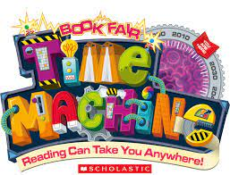Welcome Back!
Dear Families,
Welcome back to in-person & virtual family event Book Fair!
Book Fair Time Machine will take place Monday April 4th –Thursday April 7th. Book Fair hours are Monday-Wednesday 8:30-2:00 & Family event Thursday April 7th from 12:00-4:00 & 6:00-7:30
NEW: Scholastic has also added a virtual shopping option to Book Fair. Along with in-person shopping, families can shop online virtually using this link: https://virtualbookfairs.scholastic.ca/pages/5173283 This link is live from Monday April 4th until Sunday April 17th. This link will also be on our school website.
NEW: Purchases made online will be shipped directly to the school. Items will be shipped to the school after the virtual fair closes; approximately 2-3 days.
Profits from this literacy fundraiser come back to our library where new books will be purchased for our students to enjoy.
Thank you all in advance for you support during this exciting literacy fundraiser.
Sincerely,
Mrs. Gaudet
Library Support
Book Fair Chairperson.

